Head to our virtual lab

https://phet.colorado.edu/sims/html/circuit-construction-kit-dc-virtual-lab/latest/circuit-construction-kit-dc-virtual-lab_en.html

What are properties of series circuits concerning:
- Voltage used for the element(s)?
Voltage: The supply voltage in a series circuit is equal to the sum of the individual voltage-using devices.

- Current through each element?
Current: The amount of current is the same through any component in a series circuit.

Series Circuit
Lab:
1
A
B
C
2
- Create a series circuit shown to the right.

- Measure the following:

battery voltage ___100V____

voltage light 1 ___60V____ voltage light 2 _40V______

Question:
- How does this show the series property for voltage usage?
The voltage developed across the two bulbs equals to the source’s voltage. In other words, the sum of potential drop across the devices in a series circuit is equivalent to the battery voltage.

- Measure the following:

Current at point A ____0.5A__ Current at point B __0.5A_____ Current at point C ___0.5A____

Question:
- How does this show the series property for currents? (Refer to the answers in red above)

The ampere’s reading indicate that the current is the same at any point across the series circuit.

Parallel Circuit
Question:
What are the properties of a parallel circuit concerning?
a. Voltage usage for each parallel branch?
A Parallel circuit has certain characteristics and basic rules: Voltage is the same across each component of the parallel circuit.

b. Current through each branch?
A parallel circuit has two or more paths for current to flow through. The sum of the currents through each path is equal to the total current that flows from the source.

A
B
C
1
2
Lab:
Create the parallel circuit to the right.
- Measure the following:

battery voltage __100V_____

voltage light 1 __100V_____ voltage light 2 _100V______

Question:
How does this show the parallel property for the voltage in parallel branches?
The potential drop across devices in a parallel circuit is the same and equivalent to the source’s voltage.

Lab:
- Measure the following:

Current at point A ___0.20A___ Current at point B __0.10A____Current at point C _0.10A______

Question:
- How does this show the parallel property for current in parallel branches?
(Refer to the answers in red above)
The sum of currents flowing in the parallel branches is equals to the current driven by the voltage from the source.

Place each of the items listed into a circuit and list whether the item is a conductor or an insulator:

Item | Conductor/Insulator
fuse | conductor
dollar bill | insulator
paper clip | conductor
coin | conductor
eraser | insulator
hand | insulator
dog | conductor
pencil | conductor
Battery | Voltage (V)
1 | 100V
2 | 100V
3 | 100V
1+2 | 1100V
1+2+3 | 2100V

Drag three batteries onto the circuit field. Measure the voltage of each using the voltmeter and record. Measure each battery as a single battery and then measure two inked together and finally all three linked together.

Describe the relationship between the number of the batteries and the voltage.

The number of batteries is proportional to the combined voltage. An increase of an extra battery results to increment of 10 times the amount of individual battery voltage.

Use the scissors to disconnect one of the batteries and then flip the polarity of the disconnected battery. Reconnect and use the voltmeter to measure the total voltage of the three batteries again. What is the voltage reading now? Why do you think this has changed?
Voltage of disconnected battery is 1000V
The voltage of the three battery measured after reconnection is 2100V
The difference indicate that voltage is accumulated at the terminals of poles of the batteries. This is so because the batteries at the end of the connection portrayed a voltage of 1000v whereas the middle battery exhibits a voltage of 100V.

Build the circuits with a battery of 12 V and light bulbs. Using the voltmeter and the ammeter, measure the voltage and the current and complete the table:
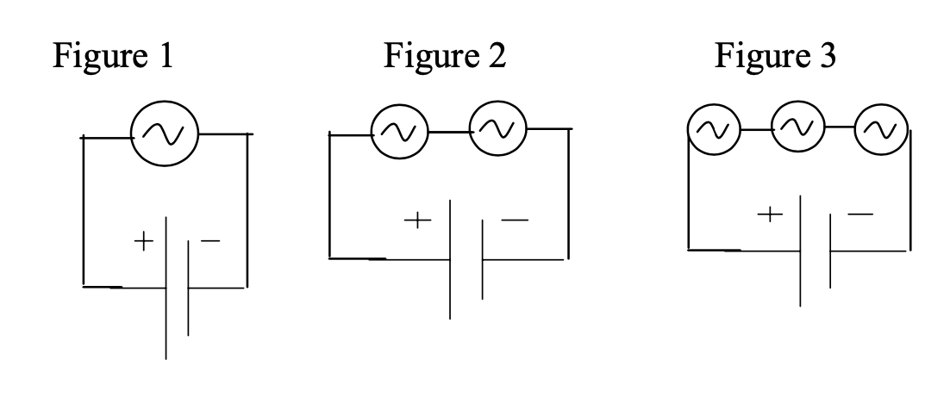
# of bulbs | Battery (V) | Current into battery (A) | Brightness of bulbs
1 | 12V | 0.05A | Bulb 1 exhibits high luminance
2 | 12V | 0.05A | Bulb 1 maintains its luminance whereas there is no brightness in bulb 2 at all.
3 | 12V | 0.05A | Bulb 1 maintains its luminance whereas there is no brightness in bulb 2 and bulb 3 at all.

Summarize the relationships you observed and explain why you think this is happening. Change the battery voltage (double or triple the voltage). Does the relationship you cited above still hold?
When the two or more bulbs are connected in series, only a single bulb that is functional and the others just act as a conductor. The relationship does not change with the increase of battery voltage since it is the luminance of the functional bulb that increases.

